**ENVIRONMENTAL ASSESSMENT REPORT**

**Environmental Assessment for the proposed water project of**

**Siha Al Fudhliya**



**Summary Report**

**Assessment of Effects and Mitigation Measures**

**July- 2020**

**Zakho Small Villages Projects (ZSVP)**

**Environmental Assessment Report**

**On**

**Siha Al Fudhliya Water Project**

**July- 2020**

# **Executive summary**

This report covers the description of the potential effects that the proposed water project in Siha- Al Fudhliya will have on the environment and proposed mitigation measures. The significance potential effects of the proposed project on environmental components were assessed according to various parameters listed within the Part II of the attached environmental assessment form (EAF); the focuses of the parameters were on intensity, duration and scope. In addition, the potential impacts of the local environmental components on the progress of the proposed project have also been considered. When needed, mitigation measures were identified to reduce the significance of the effects and ensure that the residual effects are not significant according to Environmental Sustainability and Assessment Guide provided by the MCC.

In terms of the physical environment (soil and water), the potential effects of the proposed water project on soil and groundwater were assessed based on the listed parameters related to land and water within attached EAF. Accordingly, soil and groundwater contamination will not occur due to the fact that construction works of the proposed project will not associate with any disturbance to the soil within the project area and also no water bodies is found in or near to the project area; where no chemical toxic materials will be included within the construction of the project, thus, the effects on the proposed project on physical environment are considered non-significant and no mitigation measures will be needed.

With regards to the impact of the proposed project on the air quality, based on the analysis of the related data listed within the EAF, the potential effects of the project during the construction phase will be very limited and will be below the permitted level of the emission gases from vehicles due to their limited trips for transporting of the required stuffs for the project.

The proposed project will be exclusively within the boundary of the village where no endangered or threatened plant and animals’ species are found to be affected by the activities of the proposed project during the operations phase. Besides, the proposed project will not cause any disruption to the agricultural land resources, aesthetic resources, historic and archeological resources and open spaces and recreation. Furthermore, the public transportation and the community sources of energy are not found within the proposed project area.

With regards to public health, the potential effect of the project could be associated with sound (noise) environment and odor of the missioned gases from the used machines during the construction phase of the project. Sound environment which could be affected by the construction works and vehicle trips; the effects will be limited and under the permitted level. Noise mitigation measures are planned, where trench excavation for pipe extension will be conducted by workers through cash for work. Besides, no blasting and expulsive materials will be used during the construction phase of the project. With regards to the odor, to avoid emission of any unpleasant odor or gases, the proposed project will avoid using any toxic materials including herbicides, pesticides, chemicals or radioactive or any infectious materials during the implementation of the proposed project. Furthermore, the design of the proposed project will not effect on the character of the existing community or even will not conflict with the officially adopted plan by the local authorities and municipal plan.

To sum up, analysis of the cumulative effects and the effects of the environment on the project has shown that the project will not have significant effect during the implementation of the project or even in future.  
To ensure that the proposed project will not harm the local environment and/ or the public health, during construction phase of the proposed project a careful monitoring and supervision will be conducted by the ZSVP staffs in cooperation with related authorities and village board.

# List of Figures

Figure 1. Online Map of Siha Al Fadhliya-where the picture shows wide agricultural plain areas free from any water sources. 2

Figure 2. Elevated storage tank by concrete block 7

Figure 3. Steel storage tank capacity 28m3 8

Figure 4. Plan of the elevated storage tank 9

Figure 5. Isometric elevated concrete base for the water tank 10

Figure 6. Manhole from checker plate size (80* 80 * 80) cm for gate valve 11

Figure 7. Design of the water pump room 12

Figure 8. Design of wall sections for the water well room 13

Figure 9. Windows doors for the water pump room 14

Figure 10. Plan of the water network of Siha Al Fudhliya 15

# List of Tables

Table 1. Members of environmental assessment committee for assessment the potential impacts of the project on the environmental component and the potential effects of the environment on the proposed water project in Siha Al Fadhli 3

# Table of Contents

Executive summary II

List of Figures IV

List of Tables V

Table of Contents VI

1. Introduction 1

2. Village of Siha Al Fudhliya 1

3. Purpose of the Environmental Assessment Report 2

4. Approach 2

4.1 Public and consultation approach 3

4.2 Environmental assessment guidelines 3

4.3 Assessment Methodology 4

5 Project impacts and their magnitude 15

5.1. Impact on the land 15

5.2 Impact on water 15

5.3 Impact on air 15

5.4 Impact on plants, animals and agricultural land resources 15

5.5 Impact on aesthetic resources, on historic and archeological resources and on an open space and recreation 16

5.6 Impact of the proposed project on transportation 16

5.7 Impact of the proposed project on energy 16

5.8 Noise and odor impact 16

5.9 Current conditions of the local environment and its impact on the project implementation 16

5.10 Impact of the proposed project on public health 17

5.11 Impact of the proposed project on growth and character of community or neighborhood 17

6 Environmental management plan 17

# **Introduction**

This report summarizes the information found in EAF with regards to Siha Al Fudhliya proposed water project, which provided a description of the project’s effects on the environment and proposed mitigation measures. This report provides descriptions of the location of the proposed project, project and the environment. This report provides an environmental assessment of Siha Al Fudhliya proposed water project.

There will not be relocation or displacement for any of the existing infrastructure located enclosure to the proposed project.

# Village of Siha Al Fudhliya

The village is located 35 km from the center of Rabia Sub district/ Tal Afar District/ Ninawa/ Iraq. The Siha Al Fudhliya Village population is 45 families consisting of 286 people and there are 45 students with three disabled persons. The total land of the village is estimated to be around 6000 acres used for the rain fed crops, mainly wheat and barley. Currently, the village is not located within the planning or zoning decision of the regional municipal. Besides, the area is far located from any water sources like river, pond, wetland areas and stream as it can be seen from below map.

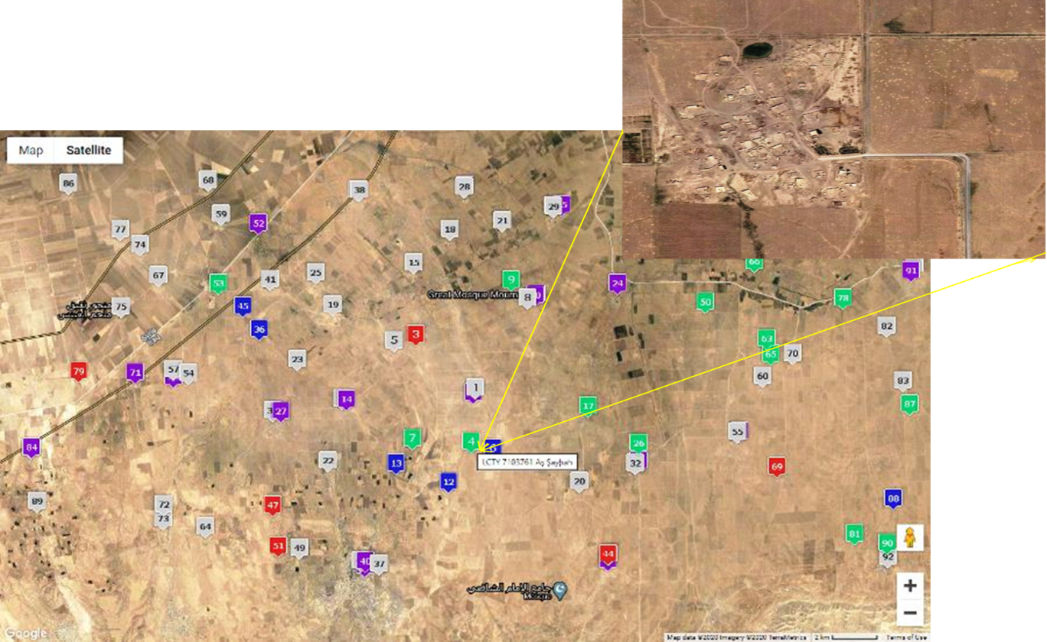

Figure 1. Online Map of Siha Al Fadhliya-where the picture shows wide agricultural plain areas free from any water sources.

The locals complain and suffer from a lack of water suitable for human consumption and the majority of the villagers suffers from unstable living conditions and need support with permanent livelihoods. The main vocations of the villagers are agriculture, animal husbandry and daily employment through cash for works. The village was abandoned for three months during the ISIS crises from January- April/ 2015.

Currently, the quantities of water are insufficient due to the productivity of the existing artesian wells which does not meet the demand of the village and there is no internal network, which forces the villagers either buying water from water tankers at high prices, amid deteriorating economic conditions, or bearing the hardships of bringing it which is usually carried out by women/ children from nearby wells which is exhausting and tiring, and time consuming. Likewise, villagers complain about their inability to create orchards, home farming, and take care of livestock because there is not enough water. Also, the outages in national electricity to extract water have exacerbated the problem.

# **Purpose of the Environmental Assessment Report**

The main aim of this assessment report on the proposed water project in Siha Al-Fudhliya is to provide a summary of information and analysis considered by the ZSVP Environmental Assessment Committee made to determine whether the project could cause any significant adverse environmental effects after taking into account the proposed mitigation measures. Besides, this report will be helpful in providing information related to designing of the project to ensure the sustainability of the project through implementation the mitigation measures to reduce any potential impact might cause by the environmental components on the project mainly during the construction phase of the project. Eventually, the designed project will not only serve the local community (public health), but also will avoid any potential damage to the local environment including animals and plants.

# **Approac**h

Due to the novelty of the subject of environmental assessment of projects in the region, and among the concerned departments and directorates and NGOs working within the area; because of projects are implemented under the supervision of the public sector and not the private sector and companies, and due to the lack of expertise and information required by the employees of the concerned departments of the related directorates, we faced many difficulties in obtaining the required licenses and letters and that is why there was delay in preparing and sending the required environmental assessment report.

The dire needs of the Siha Al Fudhliya villagers for potable water with sufficient quantities urged ZSVP with support from MCC to adopt an objective-based approach to carrying out the environmental assessment for a proposed water project involving repairing and installing a water project (potable network, water storage, well room) for Siha Al Fudhliya village/ Rabia sub district/ Sinjar district/ Ninawa/Iraq.

An objective-based environmental assessment was conducted based on the:



## 4.1 Public and consultation approach

The responsible authorities of ZSVP decided to involve the villagers and village board in the initial screening process of the proposed project as the public participation was desirable and helpful in designing and in the completion of the project later.

An initial consultation was held from September- 2018 to collect comments from the public regarding their needs for the project and description of the proposed project. The public, village board and authorities of Mosul water department were consulted again in August 2019 to inform the villagers about the design and implementation of the project.

Further, regular meetings were held between the members of a consultation committee which was made for the purpose to assess the potential impact of the proposed projects on the environment. The committee included experts from different fields related to the environment and water projects; the committee was made from 4 members two of them were from ZSVP (one logistic (Senior Mechanical Engineer with experience over than 15 years in water projects, and the other technical advisor) and the others two consultants were out of ZSVP staffs as it is shown in below table

Table 1. Members of environmental assessment committee for assessment the potential impacts of the project on the environmental component and the potential effects of the environment on the proposed water project in Siha Al Fadhli

|  |  |  |  |  |
| --- | --- | --- | --- | --- |
| # | Full name | Directorate | Duty and specialty | Position |
| 1 | Fadhil Tahir Abdullah | ZSVP | Logistic-Mechanical Engineer | Head of Committee |
| 2 | Mohammed Khalaf Salim | Director of water department/ Rabia | Technical | Member |
| 3 | Nilson Philips Khosaba | Senior Mechanical engineer | Consultation | Member |
| 4 | Nawzat Aboziad Issa | ZSVP | Technical Advisor-Veterinarian (Ph.D) | Member |

## 4.2 Environmental assessment guidelines

During the consultations, the environmental assessment guidelines were adopted and the following sections were concerned:

1. Assessment methodology (see the Assessment Methodology section below) and community participation
2. Characteristics of the local environment relevant to the project
3. Description of relevant environmental laws or standards
4. Possible benefit or harm to the environment from the project
5. Possible impact of the environment on the project
6. Identification of steps to avoid and reduce potential negative environmental impacts
7. Follow-up and monitoring plan

During the consultations, the concerns centered on the following themes:

1. Impact of the proposed project on land
2. Impact of the proposed project on water
3. Impact of the proposed project on air
4. Impact of the proposed project on plants and animals
5. Impact of the proposed project on agricultural land resources
6. Impact of the proposed project on aesthetic resources
7. Impact of the proposed project on historic and archeological resources
8. Impact of the proposed project on open space and recreation
9. Impact of the proposed project on transportation
10. Impact of the proposed project on energy
11. Noise and odor impact
12. Current condition of local environment
13. Impact of the proposed project on public health
14. Impact of the proposed project on growth and character of community or neighborhood

## 4.3 Assessment Methodology

A preformed EAF was used to assess any potentials environmental effects on the project and vice versa; the methodological approach used includes two main phases, namely, identification and assessment of potential effects. Identification of potential effects consisted in identifying the components of the physical, biological and human environments that are likely to be impacted by the project’s activities. While, the assessment of potential effects consisted of defining the scope of the effects associated with  
project execution. The significance of an effect on a component of the environment is based on parameters listed in attached EAF.

For identification of potential effects the following elements were considered:

* The project’s technical characteristics and proposed working methods as determined (see working design and plan of the proposed project section 4.5, and the used constructive materials (quality and quantities, attached file in Excel)).
* Knowledge of the environment by collecting data from the previous year and consultation with the local related directorate, see the attached data (EAF, page 7 (Descriptions of the current condition of these environmental features)).
* Lessons learned from similar projects performed by ZSVP (water project in Dubardan 2017, water project in Kaske village 2017).

According to the environmental effects assessment, the impacts were determined as:

* **Non-significant**: when the effect is temporary and/or low-return, short-lived and/or limited in scope, and has little or no impact on the environmental component.
* **Significant**: signifies that, despite mitigation measures, the residual effect has a permanent impact on the environmental component.
  1. **Approval letters**
* To validate the environmental assessment process of the proposed water project of Siha Al-al Fudhliya, approval letters were obtained from the related authorities and concerned directorates declaring no objection on the implementation of the proposed project as the project impact not cause any significant impact or changes to the environmental components, agricultural land, public health, plant and animals, see the attached approval letters including:

1. Approval letters

-Municipalities and public works/ Water National Laboratory approval letter on the water validity for human consumption (1)

-Support Letter from local authority of Rabia Sub District on the proposed project (2)

- Non-objection letter (Village board) (3)

- Well ownership proof (4)

- Administrative order for digging well (5)

- Groundwater report (6)

- Local health department (7)

- Local agricultural department (8)

1. Consultation committee

-ZSVP administrative order on forming consultation committee (9)

- Consultation committee report on the proposed project (10)

1. Design and plan of the project including:

- Elevated storage tank by concrete block (11)

- Storage tank capacity 28m3 (12)

- Plan of the elevated storage tank (13)

- Isometric elevated concrete base for the water tank (14)

- Manhole from checker plate size (80* 80 * 80) cm for gate valve (15)

- Design of the water pump room (16)

- Design of wall sections for the water well room (17)

-Design of the water network (18)

- Windows doors for the water pump room (19)

-Quantity and Quality of the constructive materials required for the proposed project (Excel file) (20).

-Plan of the water network of Siha Al Fudhliya (21)

* 1. **Design of the proposed water project**

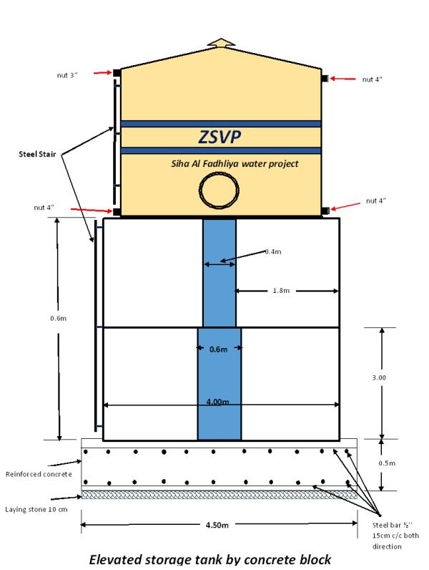

Figure 2. Elevated storage tank by concrete block



Figure 3. Steel storage tank capacity 28m3

**Hole with cover for cleaning**

**Iron plate of base thickness 6mm**

**Iron plate thickness 4mm**

**3.5 m**

**3.2m**



Figure 4. Plan of the elevated storage tank



Figure 5. Isometric elevated concrete base for the water tank



Figure 6. Manhole from checker plate size (80* 80 * 80) cm for gate valve



Figure 7. Design of the water pump room

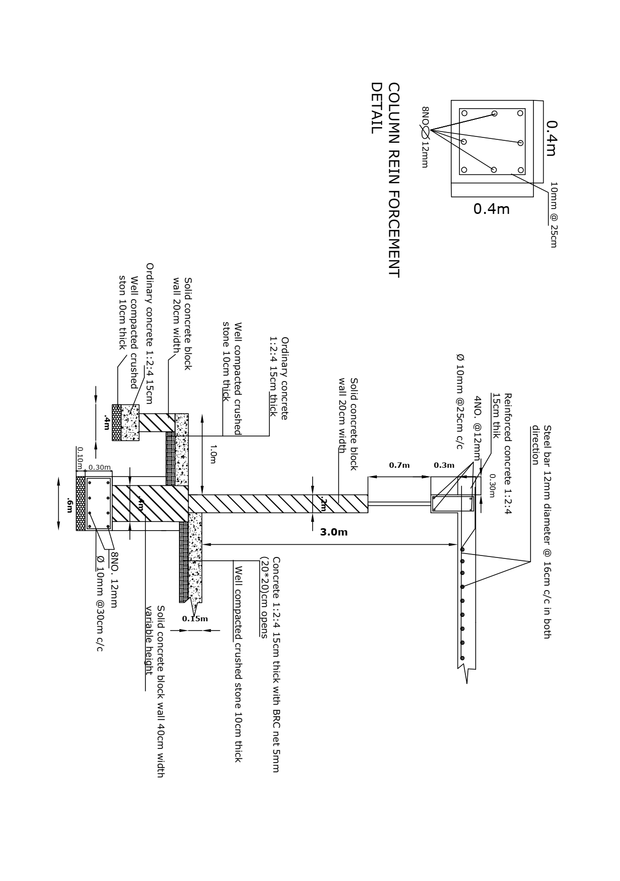

Figure 8. Design of wall sections for the water well room

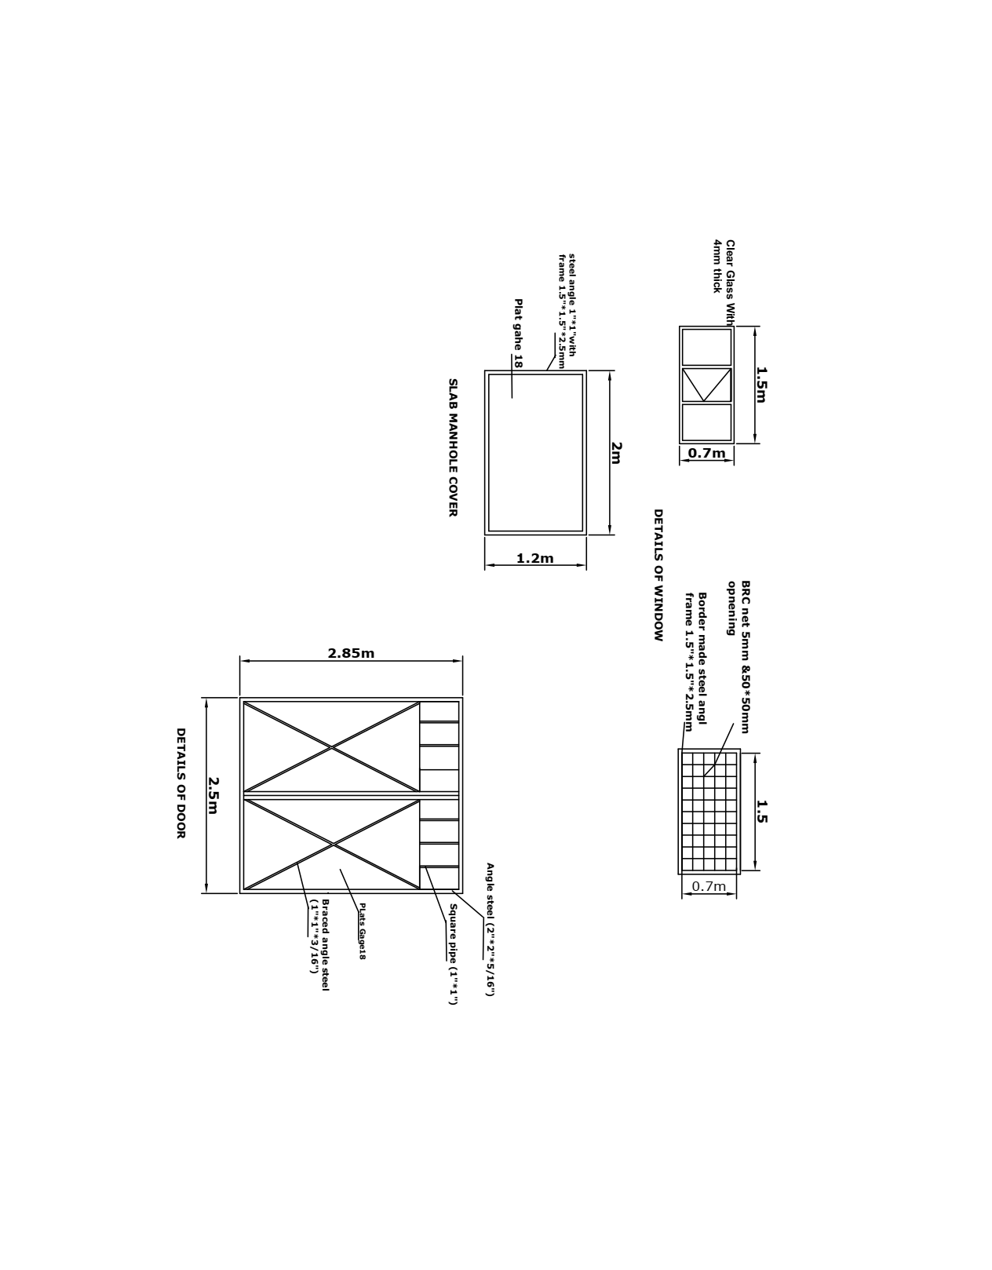

Figure 9. Windows and doors for the water pump room

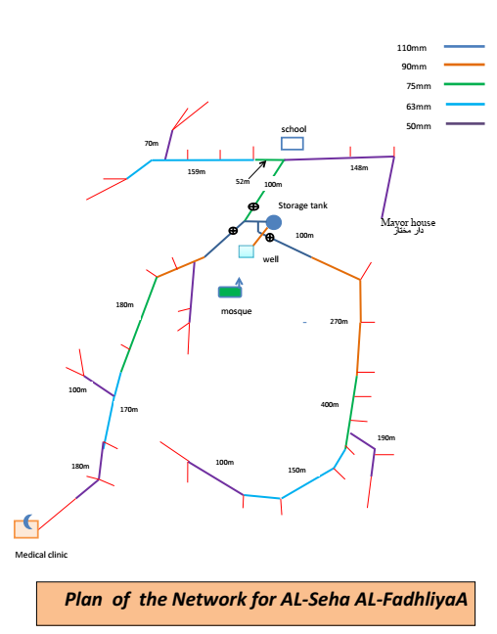

Figure 10. Plan of the water network of Siha Al Fudhliya

# Project impacts and their magnitude

## 5.1. Impact on the land

The proposed water project is located within the village of Siha –Al Fudhliya which is administratively and geographically belongs to the Rabia sub district; the allocated land for the project is exclusively confined within the village where no objection for the implementation of the project neither by the district administration nor by the villagers (see attached approval letters numbers (2, 3)). The project design is simple and is composed of excavation of land for extension of pipe line, building the basement at high (6-8m) for the storage tank and installing a galvanized water tank with a capacity of 30m3, building of well and generator rooms’. According to the field study and assessment data the project will not cause any physical change within the allocated land.

## 5.2 Impact on water

The proposed project will not have any effect on any water sources within the area; the area is an agricultural land and has no water body. Besides, the surface or ground water will not be affected as the water well is already present and the proposed project aims to distribute the potable water to the village houses through establishing home potable water network as mentioned above.

## 5.3 Impact on air

According to the estimated data collected by the consultation committee, the proposed project may have small impact on air quality which might be induced by the vehicles during working days for transferring the required stuffs. It is estimated that the total number of vehicles trips throughout the project period not exceed 4 trips and the estimated emission rate of gases will not exceed 1lb/ day which is below the limited range according to the parameters mentioned within the EAF (Section C. Impact on Air). Besides, the proposed project will not need to burn or incinerate any waste materials as there will not be any refuse left behind except some solid waste which will be moved into a far located place from the village allocated for wastes in corporation with the municipal of Rabia- Sub district.

## 5.4 Impact on plants, animals and agricultural land resources

As mentioned above, the allocated area for the proposed project is located within the village and it will not cause any danger for animal or plant life, namely on those are listed as threatened or endangered species. The design of the proposed project will not interfere with cross or cause disturbance in accessing to any kind of agricultural land within the vicinity areas. The excavation of the trench for the pipe extension will not cause any deterioration to the soil profile of the used agricultural land in the nearby areas. Moreover, the proposed project will not cause any disruption for any kind of agricultural land management system. In addition, before implementation of the proposed project, approvals will be taken in advance from the relevant authorities including Agricultural Department (see attached approval letters (2, 3 and 8)).

## 5.5 Impact on aesthetic resources, on historic and archeological resources and on an open space and recreation

Based on the consultations were made between the consultation committee members and villagers, village board and authorities of Mosul water department and according to the obtained data from the related directorates, the allocated area for the proposed project does not affect any aesthetic resources, historical and archeological resources which rather are not found within the project area. The proposed project will not interfere with any kind of scenic views or reduce their aesthetic qualities. The proposed project even is not located within the vicinity of any site listed as historic places. With regards to the effect of the proposed project on open spaces and recreation areas of the village and the nearby areas currently or in future, the project will not have any kind of impact on these areas where the project is exclusively located within the village.

## 5.6 Impact of the proposed project on transportation

The proposed project will not effect on the existing transportation system during the working days of the projects or even will not have any effect in future. The project will be implemented within the village and will not interfere with the public traffic or transferring of goods from the village to outside or to the village.

## 5.7 Impact of the proposed project on energy

Currently there is no energy or fuel source within the implementation area of the proposed project. The residential needs for the fuel, gases and any other kind of the energy are currently provided via vehicle and tankers which will not be affected by the implementation of the proposed project.

## 5.8 Noise and odor impact

As mentioned before, the current proposed project is not a complicated project and it needs limited stuffs and three months for fulfilment. There will not be any objectionable odors, noise or vibrations from the required machines for transferring stuffs and excavation when needed. The potential odor which may be originated from of the transferring machines will be very limited and may be only during transferring of the required stuffs. With regards to the noise, the proposed work does not need to use any kind of blasting. Trench excavation work will be carried by workers through cash for work. The induced noise will be very limited and will not affect the locals in vicinity villages.

## 5.9 Current conditions of the local environment and its impact on the project implementation

According to the listed data within the attached EAF regarding to the local environmental feature in terms of daily temperature, daylight, sunshine and rainfall; the local environment will not disturb the construction phase or interfere with activities of the proposed project during the project implementation period of 3 month. The predicted precipitation rate of rainfall throughout the implementation of the proposed project from August -October will not exceed 11.8mm (0.5") of precipitation and this will not have any significant effect on the construction activities of the project and thus, the project will be conducted according to the designed plan to end on its due time.

## 5.10 Impact of the proposed project on public health

The proposed project is designed to serve locals through providing them with the required sufficient potable accessible water; the proposed project intend to mitigate their suffering and reduce the dire needs of the locals of the Siha Al Fudliya where they are suffering from the difficulties in obtaining the sufficient potable water for them and their livestock.

No toxic materials such as herbicides, pesticides, chemicals or radioactive will be used during the implementation of the proposed project. By the end of the proposed project, any surplice materials originated from the trench excavation or from the used constructive materials will be removed and displaced to the allocated area by the related authorities of the Rabia sub district.

## 5.11 Impact of the proposed project on growth and character of community or neighborhood

The activities of the proposed project will not effect on the character of the existing community or even will not conflict with the officially adopted plan by the local authorities and municipal plan, as per the prior work permission document attached. Besides, the proposed project will not interfere or result in displacing of any status infrastructure or private building. Rather, the proposed project will be helpful and will provide the demand of potable water for any additional community services to be established within the village within the near future. Further, by the end of the project, the proposed project may create a job opportunity as a Project operator.

# Environmental management plan

A preformed environmental management plan will be adopted when needed to minimize the effects that the structural design and construction activities of the proposed project cause to the environment. The management plan includes complying with environmental legislation and any other applicable requirements including the process of environmental assessment, required documentation (approval letters from the related authorities) for project execution and mitigation measures (in particular those identified in EA guideline.